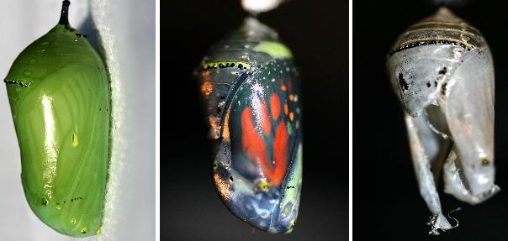
ButterFlies are Free …
& Transformation Abounds
by SandyPenny http://sandypenny.com
I’ve had many symbols throughout this spiritual journey called life. The first one was the rising sun. In the mid-1970s, in meditation, I heard a voice say, “You are the daughter of the rising sun, and this shall be your symbol.” I called out internally to the voice and said, “What does that mean?” In response, I heard, “You will come to understand, and you will know when to use it.” I sighed deeply. Very cryptic, but somehow it gave me a tingly little excitement inside. That was the beginning of learning about symbolic language for me, and the rising sun did become my symbol when I published the first metaphysical newspaper in Houston called, “The Rising Sun.”
Beginning in 2008 and continuing through 2009, the butterfly has become my symbol, and I am discovering that I’m not the only one. It seems that butterflies are everywhere right now. I was just sent a photo of a butterfly crop formation today, and it reminded me of my whole butterfly experience, an experience of transformation and magic.
Years ago, in the early summertime, I was camping with my family. I woke up with the sun one morning and was inspired to take a walk beside the crystal blue Canyon Lake in Texas. As I sauntered along a tiny path through dense foliage, I spied a beautiful bush, thick with tiny delicate flowers like nothing I’d ever seen before. The flower petals were so light that the gentle breeze was causing them to flutter in the wind. Intrigued, I walked toward the bush to examine the blossoms more closely. When I reached out to touch them, the entire bush came alive, and all the flowers flew away.
Tiny white butterflies had been feasting on the bush. It was like a scene from a Disney movie – as if the flowers had magically turned into butterflies and ascended into the heavens. It was a most mystical experience, and I wished I could have shared it with my children, but it was mine and mine alone. It brings me great pleasure to share it with you. I cannot express the joy of that little unexpected adventure. Wonderful! Natural! The magic of that transformation lifted me up, and for a moment I soared with those butterflies.
My ButterFly connection was renewed in Taos when I launched the ButterFly Healing Arts section of the HorseFly last October. That was also magical. I had proposed the section two years before, and nothing came of it. The day after I quit writing for the Taos News, in the Dragonfly Cafe, I ran into Bill Whaley, owner of the Horse Fly. I mentioned the ButterFly concept to him again, and he said, “OK, let’s try it out.” And like magic, once again, I was lifted up and flew with the butterflies.
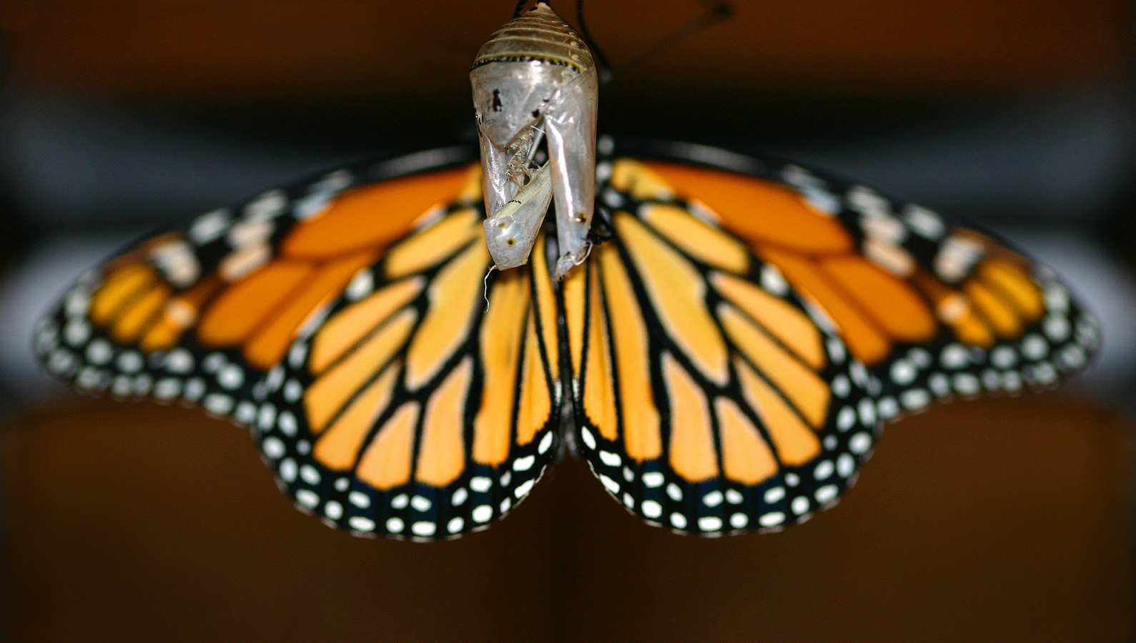
My friend Selia Quinn took some fantastic butterfly photos, beginning with a chrysalis she found on the ground and took inside and let it transform. She took photos at each stage of development of the butterfly, and she has now had a photo exhibit at the Butterfly Exhibit in the Museum of Natural Science in Houston. She too was lifted by the butterfly and flew a little closer to her dreams.
Now, a butterfly with a human body crop formation has been created, and I say our transformation has begun. Does the caterpillar know it will become a butterfly, or does it simply become one? Are we ignorant of the transformation that is occurring within us now? Why can we not see the beauty that will be born of our cocoon? This is the time of our becoming. Let the old ways drop away so we can soar to our greatest heights.
You are a ButterFly, and butterflies are free!
ButterFly Crop Circle in the Netherlands
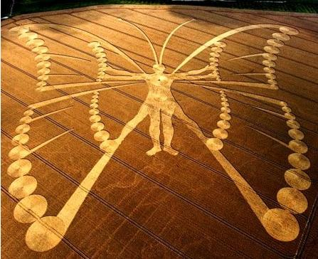
I just got word that this crop circle was created as some kind of PR thing by humans, however, you still can’t deny the imagery and its symbolic meaning of transformation. We all respond to energy in different ways, and who’s to say those who were inspired to create the crop circle weren’t responding to a higher energy as well.
The message stands on its own: time to come out of our cocoon and be as beautiful as we truly are.

